**Over-unity here simply means it produces more power than it consumes**

In the early 1980’s as a HVAC Technician, I was deeply disturbed by the number of elderly deaths during heat waves because they couldn’t afford to run their Air Conditioners or a blackout due to so many A/C’s running. These Numbers increase every year!! My device is designed to take the majority of this load of the grid entirely, and to also allow the homeowner to cool their house to their desired temperature instead of sacrificing comfort for savings. Another huge benefit is NO MORE BLACKOUTS during heat waves.

The need is now, the device is here.

It will have an immediate impact on your quality of life. It may even save the life of someone you love.

**AN OVER-UNITY POWER GENERATOR**

**THAT USES NO FUEL**

**SAVES YOU UP TO 30% ON HOME COOLING COSTS AND up to 40% ANNUALLY WITH A HEAT PUMP**

The Portable Design Will

Provide Years of Service with no additional expense after the purchase price. It is quite, fumeless and lighter than gas powered Generators.

Plus utilizing AIMS® inverter technology insures a consistent quality ac power supply to all your devices.

**THE WICKED GREEN BOX**

The Wicked Green Box

A simple 6 wire connection process!

When you connect The Wicked Green Box to the condensing unit (compressor and coil fan) you will decrease your amp draw from an average of 40 to under 8 meaning a substantial savings every month. (Set your thermostat to 18c/64f and save 30% on your electric bill anyway!)

It utilizes the latest and best in industrial inverter technology by AIMS INVERTERS ® to provide years of reliable service. It has several other benefits also.

It supplies a consistent current so your equipment is safe from spikes and brown outs. Meaning less failures and replacement costs

It can take a considerable load off our overloaded and out dated Grid System The greatest benefit is your COMFORT!

An Alternative energy that

Will Save Lives

Charles Robinson 812 Sunrise Road, Petal, MS 39465

Email: [mshempco@gmail.com](mailto:mshempco@gmail.com) (601)329-5317

Patent Pending #61476511

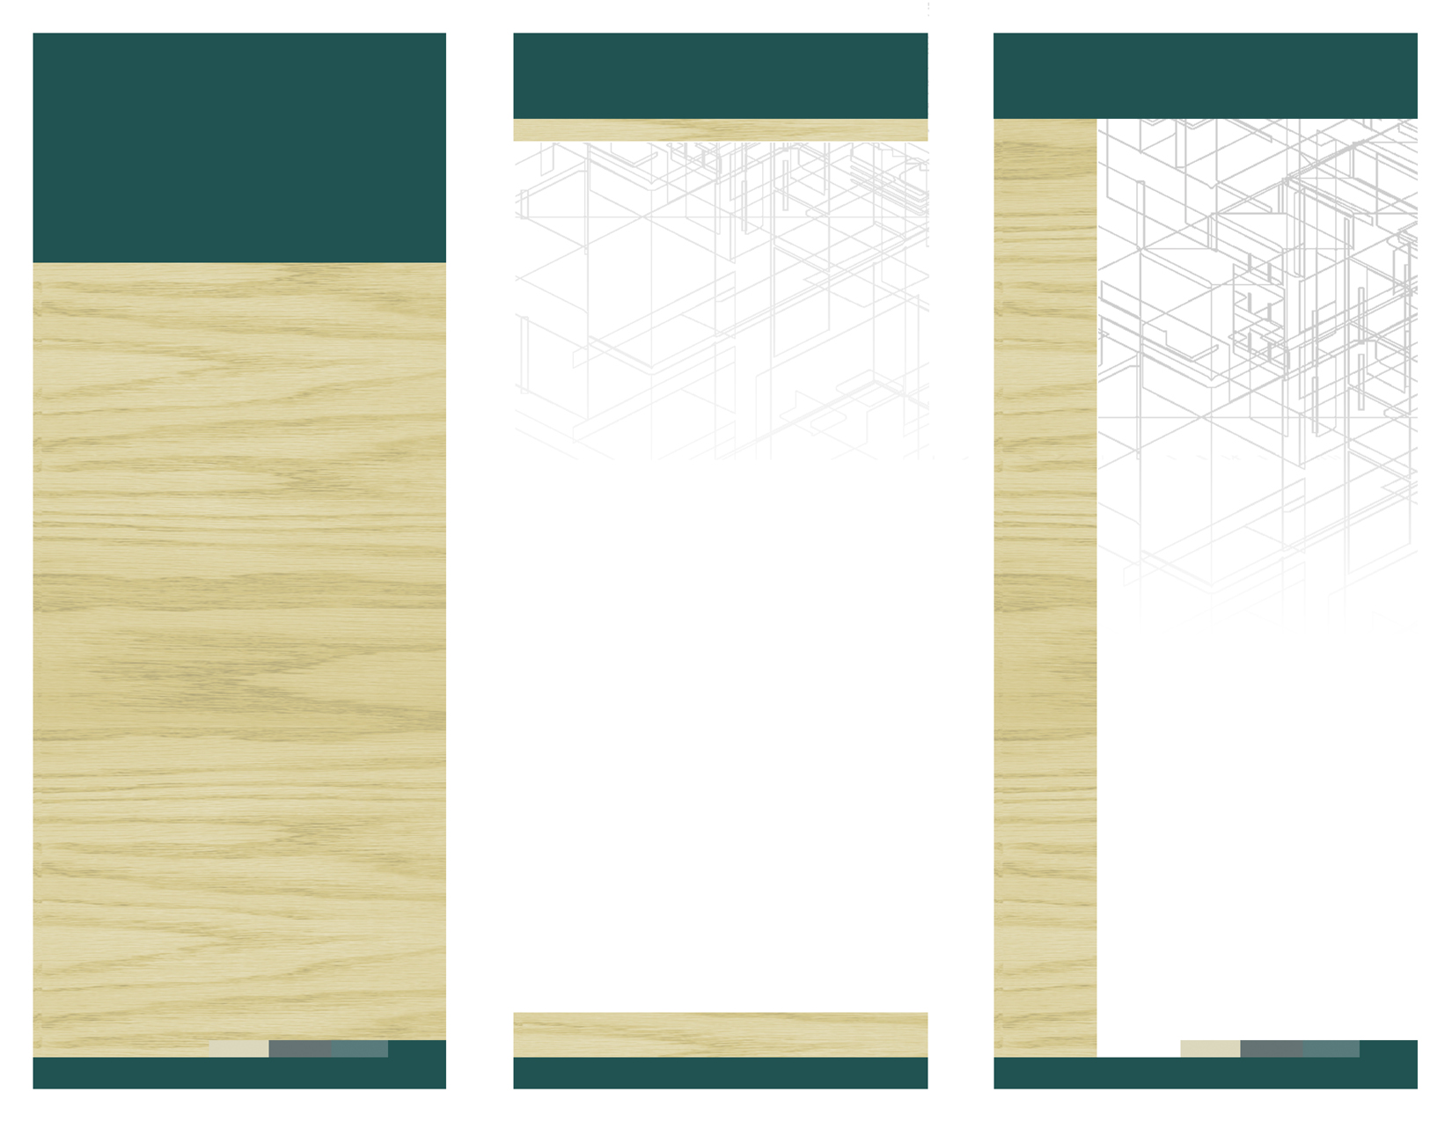

**The Wicked Green Box**

[**www.web**](http://www.web) **address here**

DELETE BOX, OR PLACE TEXT OR LOGO HERE

**Ph 555.555.5555 Fx** 555.555.5555

**5555 Street Address City, US, 55555**

**www.webaddress.com**

*Delete box or place a tag line or quote here. Delete box or place a tag line or quote here. Delete box or place a tag line or quote here. Delete box or place a tag line or quote here.*

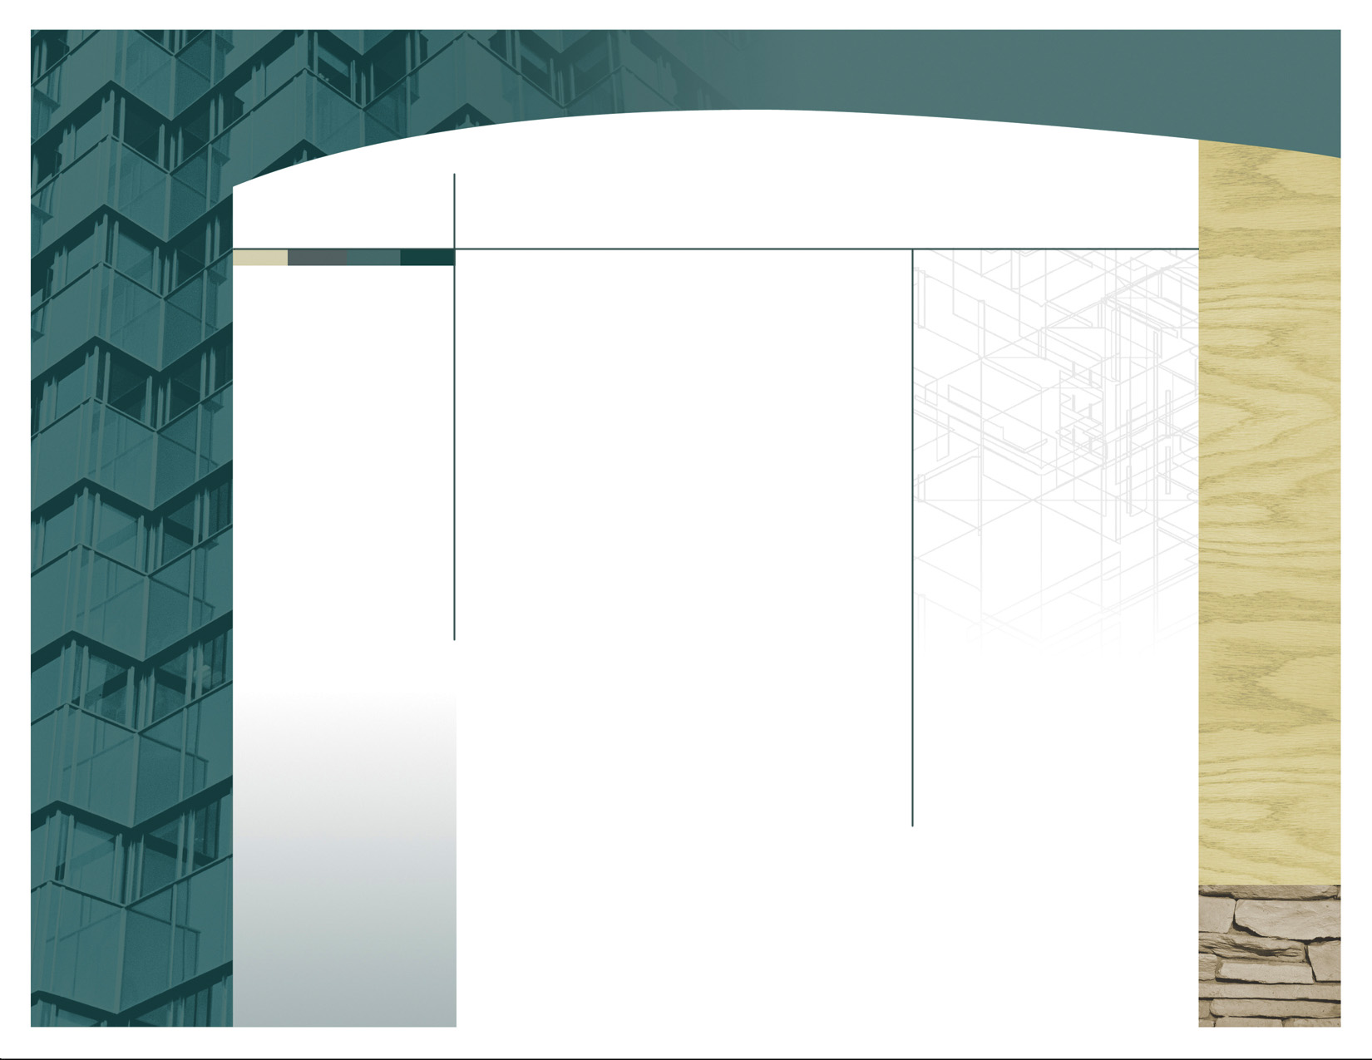

*Delete box or add photo caption here.   
Delete box or add photo caption here.  
Delete box or add photo caption here.   
Delete box or add photo caption here.*

*Delete box or place a tag line or quote here. Delete box or place a tag line or quote here. Delete box or place a tag line or quote here. Delete box or place a tag line or quote here.*

1995 Mid-West Heat wave, over 1000 deaths NOAA says were preventable! <http://www.publicaffairs.noaa.gov/pr96/apr96/noaa96-21.html>

2001 EIA Report HVAC is 31% of home energy costs <http://www.eia.doe.gov/emeu/reps/enduse/er01_us.html>

2007 EPA report 86% of American homes have Air Conditioning and use it All summer long, the time spent indoors is 87% <http://www.epa.gov/iaq/pdfs/field_climate_change_iaq.pdf>

Portable Box

Never have to refuel

Years of reliable Service

Quite and fumeless, can be brought and ran indoors

Lighter than fossil fuel engine models

Clean Inverter Power

Take to remote campsites and run electric appliances

On the Job site and save all those fuel costs

In the HOME for those power outages

Want to take your home entirely off the grid? You can do it with 3 to 4 of The Wicked Green Boxes!

The Wicked Green Box

The HVAC Version of the Wicked Green Box

Connecting the Wicked Green Box between the disconnect and the condensing unit outside your home will allow you to save an average of 80% on your monthly cooling electric bill! If you own a heat pump you will continue to see the savings in the winter! That’s over 30% on overall electric bill!

You will be able to set your thermostat at your comfort level rather than having to sacrifice that extra 5 to 10 degrees because of a large electric bill. So go ahead and turn your Air Conditioner to its Lowest setting and still see a substantial savings every month!

Using AIMS® Industrial Grade Inverters guarantees years of reliable service. All parts are readily available and with the exception of the inverter not expensive.

With a few easy modifications you can connect your oven, dryer, water heater; in fact you can have every single outlet and appliance running on these boxes and would only see the minimum charge for a month of electrical service.

My goal is to make these as available and affordable for the elderly and otherwise disadvantaged through A/C contractors to stop the senseless and avoidable loss of lives.